The default landing page is the Homepage (/)

For the requests logs (/requests) via get request

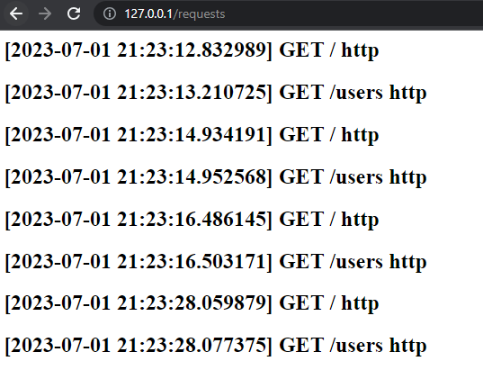

For the pagination:

The pagination returns the max pages that can be navigated.

For GET

By default, returns all record if there is no ID in input.

For POST

If the request is successful, it returns the created record via json, else if the request failed, returns status code

For PUT

Same applies to POST but returns 404 if record is not found.

For Delete

The pop up will only appear if the input has value